

|  |
| --- |
| **LAB 2** of DSA LAB |

**Submitted by:**

**Name:** Muhammad shuraim

**Roll no:** SU92-S24-BSSEM-103

**Section:** 3A

**Submitted to**

Sir Rasikh Ali

**Question 1**

#include<iostream>

using namespace std;

int find_max_value(int arr[],int n) {

int max = arr[0];

for (int i = 1; i < n; i++) {

if (arr[i] > max) {

max = arr[i];

}

}

return max;

}

int main() {

int n;

cout << "ENTER THE SIZE OF ARRAY :" << endl;

cin >> n;

int* arr = new int[n];

cout << "Enter "<< n << " Elements" << endl;

for (int i = 0; i < n; i++)

cin >> arr[i];

cout << "Maximum value in the array: " << find_max_value(arr, n) << endl;

delete[] arr;

return 0;

}

**OUTPUT**

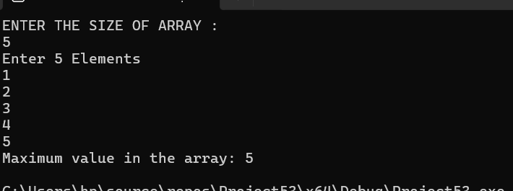

Explanation

* First I create the function (find_max_value )it initiliazes the first value max
* Then loop through the array update the value
* In MAIN ask the user for size
* I use dynamic memory allocation which allocates memory for array of size n and arr is a pointer that hold address
* Call the function in main

**Time Complexity**

**OUTPUT**

int find_max_value(int arr[],int n) //O(1)

LOOP //O(n)

Return max //O(1)

O(1)+O(n)+O(1) =**O(n)**

**Why it is?**

* Function iterates exactly once
* No of operation increase linerely with n
* Most effficiet way to find maximum value in unsorted array